**Operating Systems - Lab 03 In Lab + Post-Lab Tasks**

Ibrahim Johar Farooqi

23K-0074

BAI-4A

12 February 2025

**Post-Lab Questions:**

**Task 1:**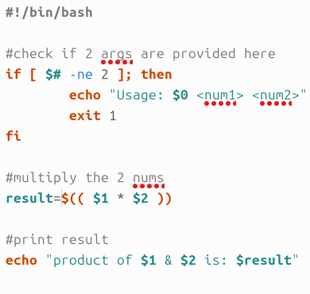

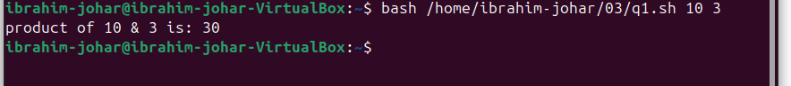

**Task 2:**

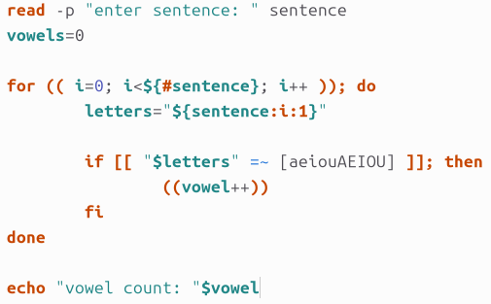

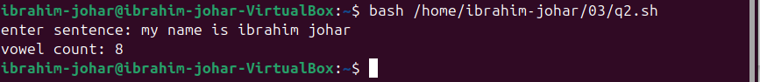

**Task 3:**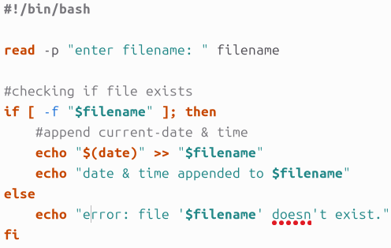



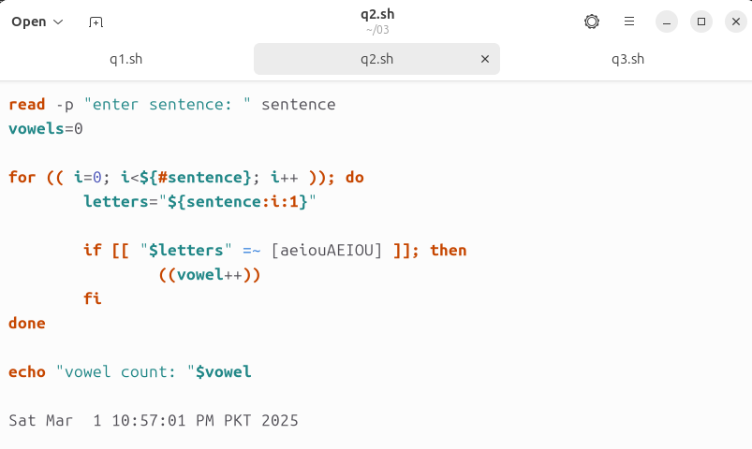

**Task 4:**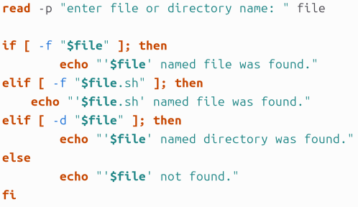

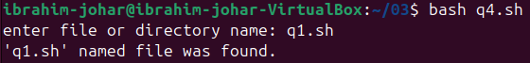

**Task 5:**

